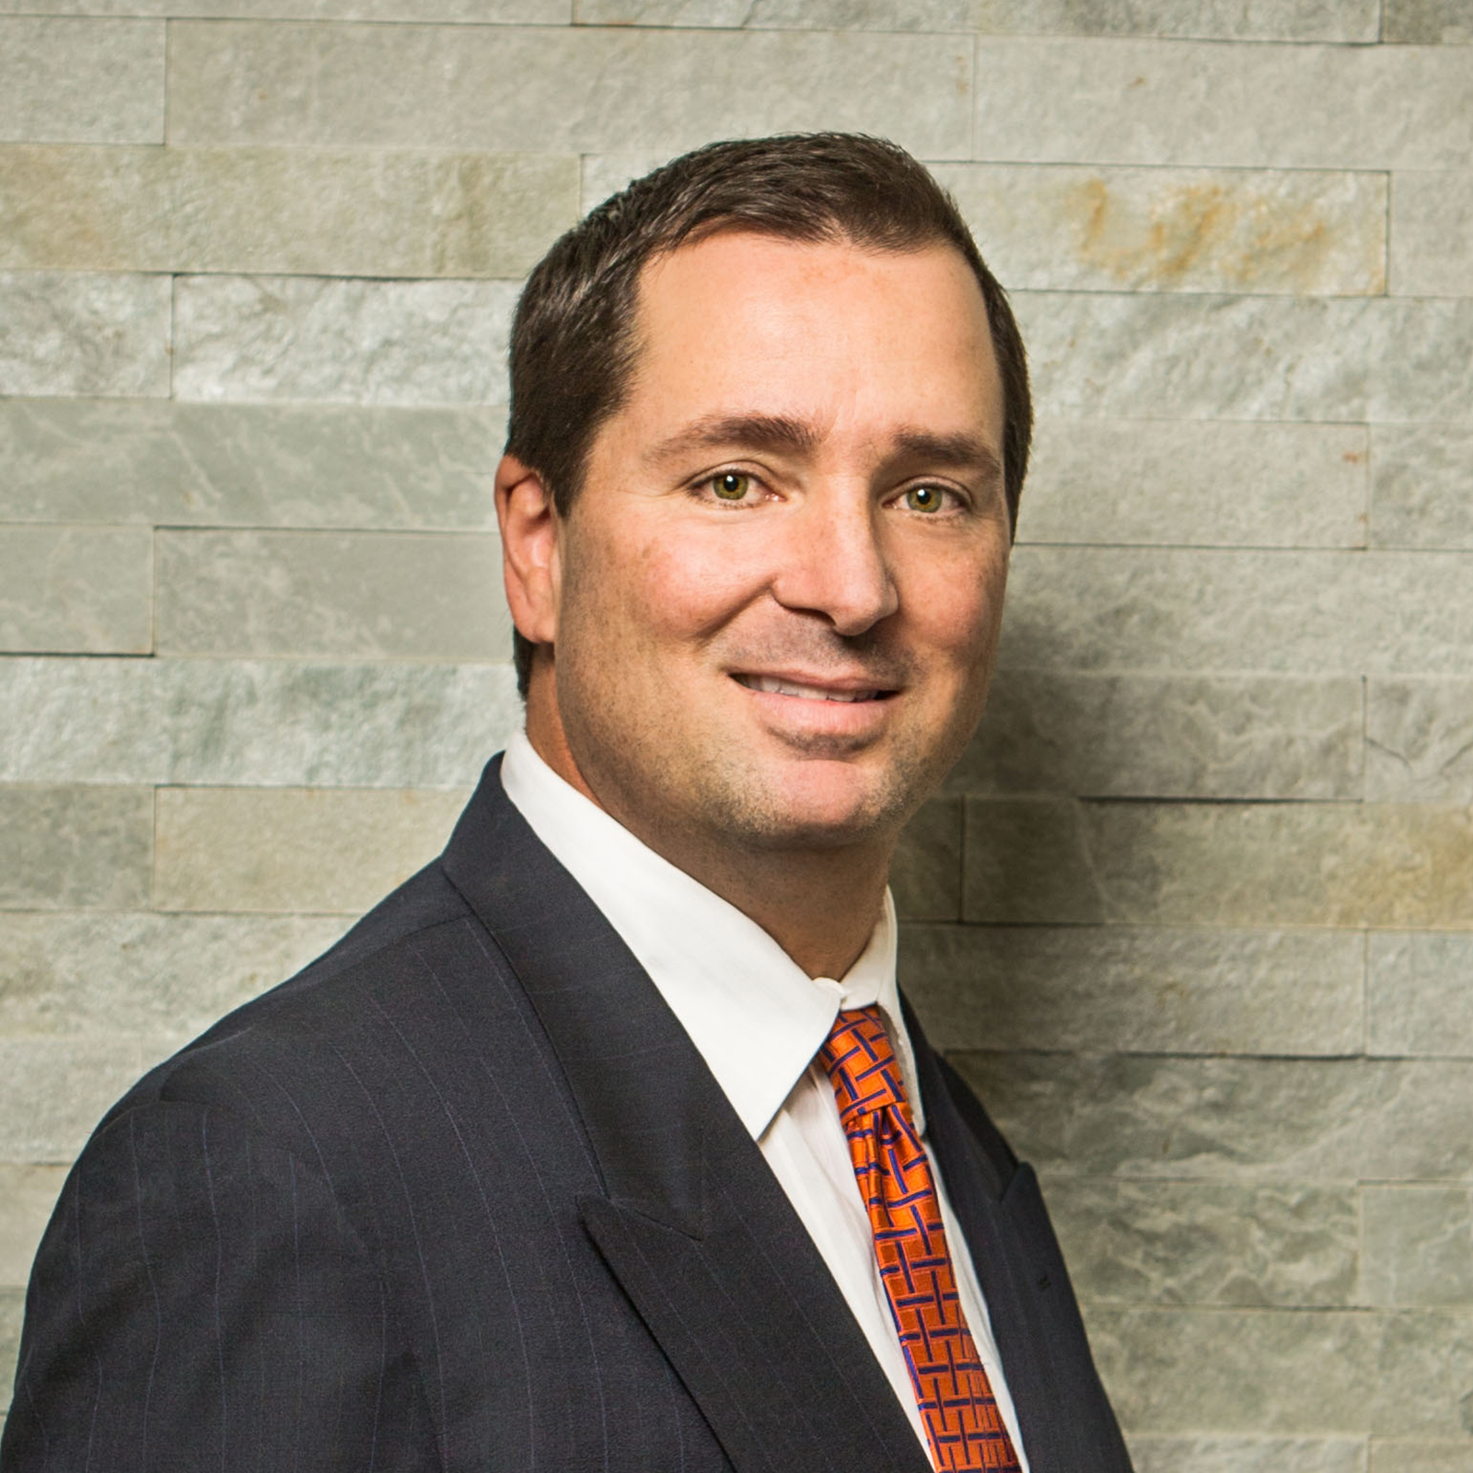 | George Marinos, CPA  CEO and Tax Partner  gmarinos@seiler.com | 650.365.4646  LinkedIn Profile

George is Seiler’s Chief Executive Officer and is the leader of the firm’s executive governing board. He has 30 years of experience in advisory, tax, accounting and finance matters. Prior to his appointment as CEO, he held various leadership positions at Seiler, including many years serving as the head of the firm’s Tax Committee, which helps provide guidance around technical tax matters and policy at the firm.

George’s experience working with ultra-high-net-worth individuals and families is extensive and ranges from income, estate, and charitable gift planning to foreign in-bound / out-bound tax matters. He serves large, multi-generational family groups; public and private company executives; closely held business owners; and general partners in venture capital, real estate, hedge fund, and private equity.

George also works with privately held businesses, including those in the real estate, high tech, software, professional services, financial services, manufacturing and wholesale industries. He consults his business clients on their tax planning, tax accounting, and compliance, as well as entity formation and structuring, transaction advisory, in-bound and out-bound matters, U.S. and foreign partner / subsidiary relationships, multi-state tax, compensation planning and other matters. He also has experience representing his clients in front of various tax authorities.

George started his career at PricewaterhouseCoopers LLP, and later joined Seiler in 1994.

Education and Certifications
- Bachelor's degree in Accounting, University of San Francisco
- Certified Public Accountant, California

Professional Affiliations
- American Institute of Certified Public Accountants
- California Society of Certified Public Accountants

Follow Seiler LLP

